BUSINESS REQUIREMENTS DOCUMENT (BRD)
Project Title
Customer Shopping Behavior Analytics Dashboard

1. Executive Summary
The purpose of this project is to analyze customer shopping behavior and provide meaningful business insights through data analytics and visualization. The solution enables stakeholders to understand customer demographics, purchasing trends, subscription performance, product popularity, and promotional effectiveness.
Data Source (CSV) → Python (EDA & Data Validation) → SQL Server (Business Queries) → Power BI (Dashboard & Visualization) → Business Insights

2. Business Objectives
The organization wants to answer the following key business questions:
- Understand revenue generation across customer demographics.
- Evaluate the impact of discounts on customer spending.
- Identify highly rated products.
- Analyze shipping preferences and spending behavior.
- Measure the value of subscription programs.
- Determine discount effectiveness by product.
- Segment customers based on purchasing history.
- Identify top-selling products within each category.
- Assess the relationship between repeat purchases and subscriptions.
- Understand revenue contribution by customer age groups.

3. Tools Used
- SQL Serve
- Power BI
- Python

4. Data Source
Dataset:
Customer Shopping Behavior Dataset
Key Attributes
- Customer ID
- Age
- Gender
- Item Purchased
- Category
- Purchase Amount
- Location
- Season
- Review Rating
- Subscription Status
- Shipping Type
- Discount Applied
- Promo Code Used
- Previous Purchases
- Payment Method
- Frequency of Purchases

5. Technology Stack
Python
Used for:
- Data exploration and profiling
- Data cleansing
- Missing value validation
- Customer segmentation
- Exploratory Data Analysis (EDA)
- Business rule validation
- Statistical analysis
SQL
Used for:
- Business requirement implementation
- Data transformation
- Aggregation
- Revenue analysis
- Customer segmentation queries
Power BI
Used for:
- Dashboard development
- KPI visualization
- Interactive reporting
- Business storytelling

6. Business Requirements
BR-01 Revenue Analysis by Gender
Business Requirement:
Calculate total revenue generated by male and female customers.
Business Value:
Helps marketing teams understand revenue contribution by customer segment.
KPI:
- Revenue by Gender

BR-02 High Value Discount Customers
Business Requirement:
Identify customers who applied discounts and still spent more than the average purchase amount.
Business Value:
Helps identify profitable customers and evaluate discount effectiveness.
KPI:
- Average Purchase Amount
- Number of High-Value Discount Customers

BR-03 Product Satisfaction Analysis
Business Requirement:
Identify products with the highest review ratings.
Business Value:
Supports product recommendation and inventory planning.
KPI:
- Average Product Rating
- Top Rated Products

BR-04 Shipping Preference Analysis
Business Requirement:
Analyze customer spending behavior by shipping method.
Business Value:
Supports logistics and delivery strategy improvements.
KPI:
- Revenue by Shipping Type
- Average Purchase Amount by Shipping Type

BR-05 Subscription Analysis
Business Requirement:
Compare spending patterns between subscribed and non-subscribed customers.
Business Value:
Measures effectiveness of customer loyalty programs.
KPI:
- Subscriber Revenue
- Non-Subscriber Revenue
- Subscriber Count

BR-06 Discount Utilization Analysis
Business Requirement:
Identify products with the highest percentage of discounted purchases.
Business Value:
Measures promotional effectiveness.
KPI:
- Discount Usage Percentage

BR-07 Customer Segmentation
Business Requirement:
Segment customers based on purchase history.
Segments:
New Customer
- Previous Purchases = 1
Returning Customer
- Previous Purchases = 2 to 10
Loyal Customer
- Previous Purchases > 10
Business Value:
Supports customer retention initiatives.
KPI:
- Customer Count by Segment
- Revenue by Segment

BR-08 Top Products by Category
Business Requirement:
Identify the top 3 products within each category.
Business Value:
Supports merchandising and inventory planning.
KPI:
- Product Ranking
- Total Purchases

BR-09 Repeat Customer Analysis
Business Requirement:
Determine whether repeat customers are more likely to subscribe.
Definition:
Repeat Customer = Previous Purchases > 5
Business Value:
Measures relationship between loyalty and subscription adoption.
KPI:
- Subscription Rate among Repeat Customers

BR-10 Revenue Contribution by Age Group
Business Requirement:
Analyze revenue contribution by customer age group.
Age Groups:
- 18-25
- 26-35
- 36-45
- 46-55
- 56+
Business Value:
Supports targeted marketing campaigns.
KPI:
- Revenue by Age Group
- Percentage Revenue Contribution

Key Insights
- Male customers contribute significantly higher overall revenue than female customers.
- A substantial number of customers continue spending above average even when discounts are applied.
- Product review ratings provide strong indicators for product promotion opportunities.
- Subscription programs generate meaningful revenue and provide opportunities for customer retention.
- Loyal and repeat customers represent valuable business segments.
- Revenue varies significantly across customer age groups, creating opportunities for targeted campaigns.

7. Data Analysis Process
Step 1:
Import CSV data using Python.
Step 2:
Perform data profiling and exploratory data analysis.
Step 3:
Validate data quality and identify inconsistencies.
Step 4:
Develop SQL queries to satisfy business requirements.
Step 5:
Create calculated measures and KPIs.
Step 6:
Load data into Power BI.
Step 7:
Develop interactive dashboards.
Step 8:
Publish business insights and recommendations.

8. Dashboard Deliverables
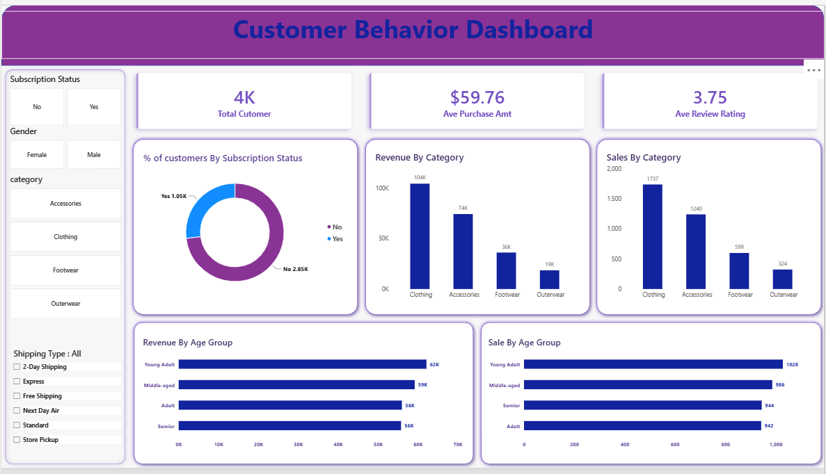

9. Expected Business Outcome
The analytics solution will provide stakeholders with actionable insights into customer purchasing behavior, product performance, and customer loyalty. These insights will support strategic decision-making, improve customer retention, optimize promotional campaigns, increase operational efficiency, and drive revenue growth through data-driven business decisions.

